***Theme: CROP PRODUCTION***

**BIOTECHNOLOGY AND BIOSAFETY IN AGRICULTURE**

**Competency**: You should be able to appreciate the emerging trends in Agriculture production and their implications.

**Learning outcomes**:

1. Know the meaning of biotechnology, bioengineering and biosafety.
2. Understand how genetic engineering is carried ut in crops and animals.
3. Be able to understand and put the case for the use and development of biotechnology in agricultural production.
4. Be able to research and understand the emerging trends in biotechnology, bioengineering and biosafety.

**Introduction**

The use of traditional plant protection means, fertilizers and breeding are now of limited help for the world's continually growing population with its increasing demand for food. Biotechnology methods promise to have the power to lower the cost of food production, to increase yield and to produce food of higher nutritional value. Applications of biotechnology in agriculture are mainly concentrating on the genetic modification of existing plant and animal species.

**Meaning of Biotechnology, Bioengineering and Biosafety**

Biotechnology is defined as any technological application that uses biological systems, living organisms, or their derivatives, to develop or modify products or processes for specific use. Biotechnology involves a wide range of procedures for modifying living organisms such as plant and animal improvement through breeding programs that employ artificial selection and hybridization. Modern usage also includes genetic engineering as well as cell and tissue culture technologies.

**Genetic Engineering (also called genetic modification)**

Genetic engineering is a technique involving reconstructing cell DNA using biotechnology such as inserting new genes, deleting genes, or inducing mutation. It is a controlled manipulation of an organism's genome using recombinant DNA technology. Genetic engineering allows desirable genes to be transferred from one organism to another and also between nonrelated species. In this sense, genetic modification means the implantation of genetic material from one species into the DNA of other species where "natural" cross-breeding does not function.



**How is genetic engineering done?**

Combining DNA through natural sexual reproduction can occur only between individuals of the same species. Technology is, however, available that allows the identification of genes for specific, desirable traits and the transfer of these, often using a virus as the vector, into another organism. Comparable to a word-processor's 'cut-and-paste', this process is called recombinant DNA technology or gene splicing. Virtually any desirable trait found in nature can, in principle, be transferred into any chosen organism. An organism modified by gene splicing is called transgenic or genetically modified (GM). Specific applications of this type of genetic engineering are rapidly increasing in number; in the development of transgenic plants and animals, and in several other fields.

Genetic engineering is a process that uses technology to alter the DNA make up of an organism. This may involve changing a single base pair (A-T or C-G), deleting a region of DNA or adding a new segment of DNA. There are five basic steps in genetic engineering;

1. DNA extraction; here, DNA is extracted from an organism known to have the desired trait
2. Gene cloning: the gene of interest is located and copied. 
3. Gene modification: the gene is then modified to express in a desired way by altering and replacing gene regions. 
4. Transformation: the genes are derived into tissue culture cells,
5. Back cross breeding: transgenic lines are crossed with elite lines to make high yielding transgenic lines.

The organisms (plants and animals) whose genes have been altered by manipulation are called Genetically Modified Organisms (GMOs). If genetic material from another species is added to the host, the resulting organism is called transgenic. If genetic material is from the same species or a species that can naturally breed with the host the resulting organism is called cisgenic.

**Biosafety**

I think COVID-19 and its impact on the people is still fresh in your minds. COVID-19 is a new virus to the public. It is believed by some people that it is a product of biotechnology, and that

its release from the lab was as a result of a human error. The outbreak of COVID-19 has encourage worldwide attention to reconsider the importance of biosafety due to the adverse impact on human life.

**Biosafety** refers to the safe development, transfer, application and utilisation of biotechnology and its products. It refers to the need to protect the environment and human health from the possible adverse effects of GMOs and products resulting from biotechnology. The developers and users of GMOS and products resulting from biotechnology must take safety  measures to address potential hazards and risks for human health and the environment.

Biosecurity refers to the protection, control and accountability measures implemented to prevent the loss, theft, misuse, diversion or intentional release or retention or transfer of biological  materials and agents.

Terms use in Biosafety and Biosecurity

**Agro-terrorism:** The act of any person knowingly or maliciously using biological agents or violence as weapons against the agricultural industry and the food supply.

**Biological agent:** Biological agents that can be used in bioterrorism or biological warfare listed

e.g. anthrax, Escherichia coli and Listeria monocytogenes).

**Bio-security:** Protection from the risks posed by biological organisms to the economy, environment, and the health of people and animals.

Bio-terrorism: The use of biological agents, such as pathogenic organisms or agricultural pests, for terrorism purposes.

Hazard: Anything that has the potential to cause injury or harm; a source of danger.

Hazard analysis: Identifying the range of risks that may impact an operation. It should reveal what can occur, how often it is likely to occur, and how serious the effects might be.

Hazardous Waste: Any solid, liquid, or contained gaseous material that is no longer used or needed, which has the potential to cause injury or death, or pollute the environment. Risk: The potential for realization of unwanted, adverse consequences to human life, health, property, or the environment.

Risk assessment: The process of establishing information regarding acceptable levels of a risk and/or levels of risk for an individual, group, society, or the environment.

Risk management: The process by which risks to an operation are anticipated or recognized and the risks removed or decreased to an acceptable level by intervention.

Safety: The freedom from those conditions that can cause danger, risk, or injury

Food safety: The process of protecting the food supply against intentional/unintentional contamination by setting standards in the industry.

# **Application of Genetic Engineering in Agriculture**

**In Crops**

Genetic engineering in agriculture has led to the production of transgenic crops such as soybean, maize, wheat, rice, cotton, potato, and tobacco that include benefits in industrial processing and agronomic productivity. Among the modifications, tolerance to herbicides and resistance to insects and disease are the predominant traits in current genetically modified (GM) crops.

**Genetic engineering can be used to improve crops in the following ways:**

1. Making crop plants more tolerant to environmental extremes, e.g. able to survive drought, cold, heat, salt etc.
2. Creating plants that can adapt to different soil conditions.
3. Developing crops that are resistant to specific herbicides. This helps to use herbicides to kill weeds without killing crops.
4. Reducing the use of agrochemicals, leading to a more environmentally acceptable agriculture that is truly sustainable.
5. Creating crops that are resistant to insect pests by inserting a gene in crops that kills pests. This reduces the use of pesticides in crops.
6. Used to improve the nutritional value of crops. For example, the low level of iron and beta carotene in rice can be checked through inserting gene from wild rice and other plants to improve absorption of iron and to make beta carotene, a precursor to vitamin A.
7. Important commercial values such as sweetness, juiciness and ripening in fruits can be improved through genetic engineering.
8. The size and yield of crops can be increased very fast in crops through genetic engineering.
9. Creating crops that can be stored and transported longer without spoiling.

**From the above, genetically engineered crops show the following characteristics:**

1. Tolerant to drought
2. Adapted to variety of soil conditions
3. Resistant to pests and diseases
4. Have high nutritional value
5. Grow and mature faster
6. Give high yields
7. Tolerant to pesticides

**In Animals**

The tradition system of selecting and breeding of the best animals has somehow proved to be slow and inefficient. Now, many farmers are switching to the use of genetic engineering techniques improve or modify farm animals. Some farmers add growth hormone to the diet of animals to increases growth in beef stocks and milk production in diary stocks or even egg production in layers. Previously the growth hormone was extracted from the brain of dead animals. But now the growth hormone is introduced into bacteria. The bacteria produce the hormone so cheaply that it is practical to add it as a supplement to the animal’s diet.

By altering the gene responsible for growth hormone production, scientists have stimulated natural growth hormone in animals, increasing their growth and weight gain. Through these procedures it may lead to creation of new breeds of very large and fast-growing animals.

Benefits of genetic engineering in animals

1. Animals can be genetically engineered to be resistant to most pests and diseases this reducing death and cost of buying drugs on the farm.
2. Genetically hormones can help increase growth and productivity of farm animals.
3. It can be used to make special proteins for use as drugs and to make more effective vaccines
4. Some animal genetic disorders can be eliminated or treated with gene therapy.
5. Animals can be genetically engineered to make them more adaptable to different climatic conditions. This makes keeping of exotic animals in tropics possible.
6. Through genetic engineering, asexual reproduction in animals is possible through cloning. This helps to produce genetically identical animals on the farm.

**Disadvantages of GM crops**

1. Cost of GM seeds is high.
2. Genes from genetically modified plants may pass to closely related weeds through outcrossing, thus, producing species of weeds resistant to herbicides.
3. Due to un-controlled breeding in most plants the modified genes may find their way wild making the wild species of plants such as weeds difficult to control by herbicides.
4. Some useful insects such as pollinators may also be affected by some insect killing g  incorporated in plants. This in the future may reduce pollination and finally reduce
5. Modified genes may also find their way into human population, increasing genetic def and possibility of ailments such as cancer.
6. Limited planting seeds; genetically modified plants gradually lose hybrid vigour requiring'* buying of new seeds each planting season. This is rather expensive and irrational to most! farmers. Traditionally, farmers saved their own seeds from harvested crops year to year.
7. May encourage farmers to overuse herbicides to control weeds and with time, making with few weed-control options.
8. With time pests may become resistant to the toxins in plants, leading to pest resurgence.
9. The genes may be passed on to some pests making them more aggressive and difficult to control, and in some cases, may lead to development of secondary crop pests.
10. Crop genetic diversity may be reduced due to the development of superior genetically modified strains that crowd others out of the market. This may be due to farmers’ preference of genetically modified organisms over the native strains.
11. Genetically modified organisms may present a food safety risk such as introduction in the food supply of a potential allergens or toxins.
12. GM crops may be difficult to sell in the market due to consumer rejection.

In spite of its importance, biotechnology has become highly controversial in Uganda, not o within the scientists but also the public. The main controversial issues focus on four areas: concerns about potential harm to human health. environmental concerns, ethical concerns related to interference with nature and individual choice and concerns related to patent issues.

**Limitations of genetic engineering**

1. It requires high skills to develop and monitor the GMOs.
2. The equipment and reagents used are very expensive and not readily available in Uganda.
3. There is negative public perception of genetic engineering technology and GMOs.
4. The population is generally ignorant about the merits of genetic engineering and GMOS•
5. Genetically modified organisms have a social rejection from the people and as such have low market and value in most countries.
6. There is no clear low governing and regulating the genetic engineering technology in Uganda.
7. There is too much government restriction on the genetic engineering technology and use of GMOs in Uganda.

viii. Restriction on the GMOs on the world market discourage farmers and service providers from adopting and using GMOs in commercial farming.

**Bioremediation**

Bioremediation is the application of biotechnology in the treatment and reuse of waste products. It is normally used to transform waste and purify water or the soil. This process mainly uses microorganisms. Let us see how these microorganisms act in some of the most commonly implemented bioremediation today:

* Biological treatment plants: a colony of microorganisms decomposes the organic matter the wastewater.
* Bioremediation of polluted soil: the colony of microorganisms is sown on a plot of land with specific pollution and the colony of microorganisms metabolises the pollutants.
* The digestion of oil slicks: the microbes metabolise the carbohydrates spilled from the oil.

**Benefits of Bioremediation**

1. Reduces the cost of waste disposal on the farm and the community.
2. Reduces environmental pollution.

Emerging Trends in Biotechnology, Bioengineering and Biosafety

Biotechnology has played a crucial role in improving human health by developing new medicine and therapies, enhancing food production, and advancing industrial processes. Over the last years, a tremendous amount of research has been and still is being done in biotechnology, bioengineering and biosafety. Since the outbreak of COVID19 pandemic, there has been accelerated development and adoption of biotechnology, with the hope that it will lead to new solutions for major national and global challenges, including diseases, food shortages, and damage to the environment. Biotechnology holds significant promises for the future, but it must be carefully regulated to ensure that the benefits are maximised while risks are minimised.

Staying updated with emerging trends in biotechnology is essential for you as a young scientist. This is because biotechnology is rapidly evolving field and discoveries and innovations are constantly being made. Some of the emerging trends in biotechnology include:

1. Use Of biotech in healthcare to present new innovative ways to diagnose and treat diseases.
2. Use of biotechnology to transform agriculture and food production, making it more sustainable, efficient, and nutritious. For example, producing rice fortified with vitamin A, producing soya that tolerates certain herbicides and of high oil and milk content. Producing farm animal that are efficient in feed utilisation, fast growth rate, more milk and meat yield, resistant to diseases and parasites etc.
3. Use of biotechnology to transform industrial processes; making industrial processes more sustainable and environmentally friendly. Biofuel and bioenergy production are among the most significant, providing a renewable alternative energy to fossil fuels. Enzyme engineering and use of genetically bacteria to destroy plastics are some of the many emerging developments.

Uganda just like many other countries is putting in place regulatory frame works to ensure the safety and efficiency of biotechnology products (read Uganda Biotechnology and Biosafety Policy and the Uganda National Biotechnology and Biosafety Bill, 2012). Research and outline some of the guidelines Uganda has so far put in place to regulate biotechnology.

Uganda government can accelerate development and adoption of biotechnology by; training more manpower in the field of biotechnology, increasing investment into biotechnology, improving markets for biotechnology products, reducing restriction on biotechnology, reducing the cost of biotechnology products for consumers, encourage international acceptance of the biotechnology.

Animal cloning and Genetic Engineering

Cloning Farm Animals Is A Mechanism For Producing Exact Copies of An Existing Animal. Once A Genetically Engineered Animal Has Been produced, The Simplest way Of Making Multiple Copies of That Animal Is By Cloning.

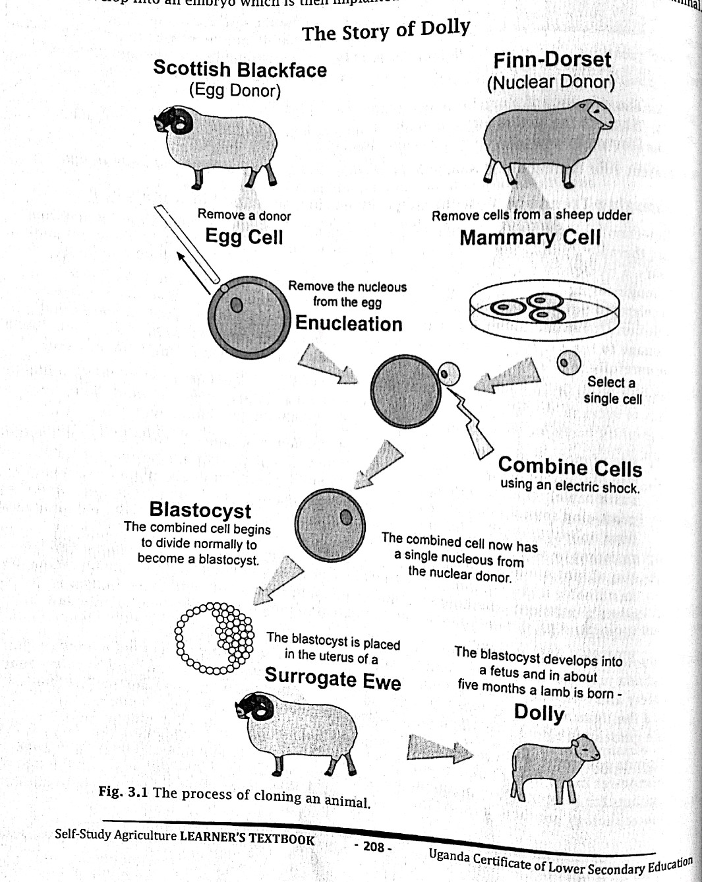The first mammal to be cloned was Dolly the sheep in 1996. Since then many animals including pigs, cattle, goat, sheep, rabbits, horses etc, have been successfully cloned. The process involves removing the nucleus (which contains the DNA) from the egg cell and replacing it with the nucleus from a body cell taken from another animal of the same species. The egg is then activated to develop into an embryo which is then implanted in the uterus of a 'surrogate' mother animal.



**Tissue Culture Biotechnology**

Plants usually reproduce by forming seeds through sexual reproduction, or regrow from buds.

However, researchers have now developed several ways of growing exact copies of plants without seed. And they are now doing this through a method called 'tissue culture'. Tissue culture is a biotechnology technique of cultivation of plant cells, tissues, or organs on specially formulated media. Under favourable conditions, an entire plant can be regenerated from a single cell. Tissue culture is seen as an important technology for the production of numerous genetically identical plants from one single parent plant known as Soma clone or Micropropagation. Micropropagated plants are usually disease-free, high quality planting material which grow more vigorously and mature faster, have uniform production cycle, and produce higher yields.

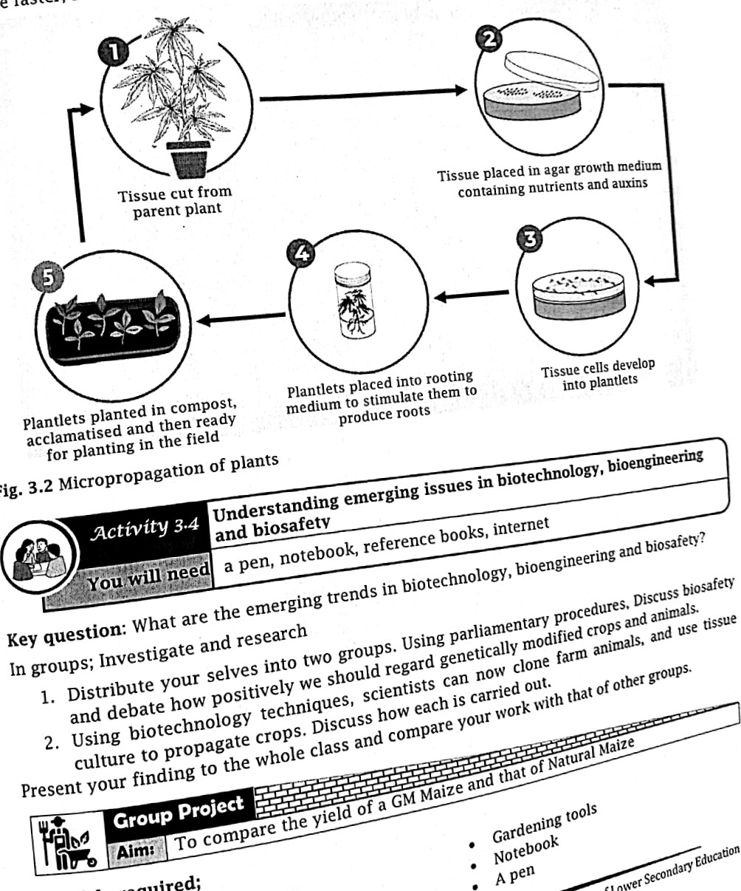

*Theme:* ***AGRICULTURAL ECONOMICS***

**LAND TENURE SYSTEM**

**Competency**: You should be able to appreciate land reforms in Uganda

**Learning outcomes**

By the end of this chapter, you should be able to:

1. Know and understand the land tenure system, tenure types and land legislation of Uganda
2. Be able to obtain information from land tenure documents and maps
3. Be able to distinguish between land reform and land registration
4. Be able to promote land reforms

# **Introduction**

Land tenure is the period or conditions or terms under which land is owned and used in given society. or, the pattern and structure of ownership of land in a given society. Different have different land tenure systems. A Land tenure system should answer the following key es questions about land.

1. Who owns land?
2. How can land be acquired and disposed of? In E. Africa land can be acquired in one following ways; buying from owner who holds a title deed, renting, inheriting from ancestors, being a number of cooperative, being member of community, or as a squatter.
3. How is ownership passed on from one owner to another?

## **Systems of Land Tenure in Uganda**

The land act 1998 identifies the four forms of land tenure systems in Uganda which include customary, leasehold, freehold and mailo.

**Customary (Communal) Land Tenure System**

Customary tenure is the most common tenure system in Uganda whereby access to land. "governed by the customs, rules, and regulations of the community." Holders of land under the customary system do not have a formal title to the land they use, but generally have secure tenure. This form of land ownership is common in the northern parts of the country.

Land is held as a communal resource. All members of the community are free to use the land for acceptable activities. The land is held by communities in form of clans, tribes or. families. Because of communal ownership, individual developments on the land like fencing, construction of permanent structures and planting of long term (perennial) crops is not possible.

**Advantages of customary land tenure**

1. Even the poor people who cannot afford the cost of owning land under freehold or leasehold land tenure system can get access to land under customary land tenure system.
2. The system fosters cooperation and unity among the land users.
3. Effective land utilization is realized unlike in freehold and leasehold land tenure systems where a person may hoard land. In customary land tenure system, chiefs or clan leaders identify idle land and distribute it to people for utilization.
4. It minimizes the risk of losing land through collateral mortgage/security.
5. It ensures grazing rights to all.

**Disadvantages of customary land tenure**

1. Over stocking and over grazing can easily take place due to uncontrolled number of stocks from the communities on the land.
2. Because the land does not belong to an individual, there is no incentive to manage and develop the land. Farmers do not risk developing the land since they can be driven away from the land at any time.
3. Because an individual does not possess a title deed for the ownership of the land, it is difficult to use such land as mortgage to secure a loan from financial institutions.
4. Introduction of new farm techniques and new production modes such as enclosing the landby fencing is made impossible.
5. Over cropping and land degradation is experienced in areas of high population pressure.

vi. Increases land fragmentation especially in areas of high population pressure.

vii. Usually conflicts may arise between the cultivators and pastoralists due to lack of fencing.

**Leasehold Land Tenure System**

Under this system land is owned by landlords who lease it out to those willing to use it for a givenperiod of time. The tenant pays rent to the landlord as agreed. Leasehold land tenure is either short-term, taking 49 years or long-term, taking about 99 years.

**Disadvantages of leasehold tenure**

1. Landlords usually exploit tenants by charging high rent which discourages them resulting into low productivity of land.
2. It results into landlessness and poverty especially when landlords evict people at short notice.
3. Mishandling of land by tenants since they know that the land is not theirs. This results into decline in soil fertility, and soil degradation.
4. Landlord may be tempted to rent their land to small scale farmers, encouraging small scale production.

**Freehold Land Tenure System**

Freehold tenure is a system whereby owners of the land have a title to their land which allows them to hold the registered land indefinitely. The landowner is given complete rights to use, sell, lease, transfer, subdivide, mortgage and donate the land as they see fit, so long as it is done in a manner consistent with the laws of Uganda. 

**Advantages of freehold land tenure system**

1. The title deed provided can be used as collateral security to acquire loans from banks.
2. Land can easily be passed on to the next of keen. iii. It settles and avoids boarder disputes.
3. It facilitates consolidation of fragmented land.
4. It gives the owners the incentives for long term investment on the land.

**Disadvantages of freehold**

1. Where land is inherited it can lead to land fragmentation.
2. It encourages inequality in land ownership and thus leads to poor resource utilization.
3. Because land is divided into small plots, it hinders large scale commercial agriculture.
4. It encourages hoarding of land by owners

**Mailo Land Tenure**

This system is only found in Uganda especially in the central region where land was allocated by the colonialists to chiefs and the Kabaka (King of Buganda) under the 1900 Buganda agreement. It is locally called Mailo Land because it was allocated in chunks spanning several miles. In this system, land belongs to the royal family, chiefs and the king of Buganda. Landlords are free to sell it, pass it on to their next of kin or allow tenants to settle on it temporarily on payment of a fee called "Obusuulu"

**Disadvantages of mailo land tenure**

1. Squatters lack security of tenure and are usually evicted sometimes without being compensated.

This discourages capital intensive commercial farming.

1. Most of the land owners are absentee landlords who leave the land idle and unutilized.
2. Squatters are not allowed to make permanent developments on the land and this leads to under development and wastage of land.
3. Conflicts between squatters and land lords over the right and usage of land are common.

**How the current land tenure system has affected Agriculture production in Uganda**

1. In some areas land is fragmented hence limiting mechanization. This confines agriculture production to subsistence
2. Communal land ownership encourages reckless use of land leading to problems like overgrazing and land degradation.
3. Lack of land titles hinders farmers from securing credit from financial institutions. This limits the potential of farmers to invest in production.
4. Investment in agriculture is discouraged due to limited access to land by potential agricultural investors.
5. Lease land tenure system reduces incentive for increased production by tenants as they pay in kind or monetary terms part of their output or incomes.
6. Increased land disputes causing anxiety and reducing farmers ‘incentive to increase production.
7. Leasehold and communal land ownership discourage long term investments and use of capital-intensive production technologies.

**The Land Legislation of Uganda**

Land legislation is all about formulation of law that involves or regulates land and its use. The Land Act provides for the tenure, ownership and management of land; to amend and consolidate the law relating to tenure, ownership and management of land; and to provide for other related incidental matters.

In 1988, a Land Committee was established under the Ministry of Agriculture to look into possible reform of the 1975 Land Reform Decree. The 1995 Constitution set a policy framework with a strong orientation towards the democratization of property relations. The Land Act No. 16 of 19 amended in 2004 and 2010, Reformed the 1975 Land Reform Decree.

***The main objectives of the Act are:***

1. To provide security of tenure to all land users, mainly customary landholders, referred to customary tenants on public land, and the lawful or bona fide occupants on registered land.
2. To resolve the land use impasse between the registered owners; mailo, freehold and lease and the lawful and bona fide occupants of this land. Prior to the passing of the new land la substantial areas of potentially productive rural land remained idle or underutilized because of lack of incentives to invest on the part of either registered owners or tenants. Registered owners had difficulty evicting tenants in order to develop the land, while tenants lacked sufficient security. This has also inhibited land markets in urban areas where buyers could not acquire secure property holdings;
3. To recognize customary tenure as legal tenure equal to other tenures;
4. To provide an institutional framework for the control and management of land under a decentralized system;
5. To ensure proper planning and well-coordinated development of urban areas;
6. To ensure sustainable land use and development throughout the country to conserve the environment;
7. To redress historical imbalances and injustices in the ownership and control of land;
8. To provide for Government and local government to acquire land compulsorily in the public interest and for the public use, public safety, public order, public morality or public health

**Customary Ownership:**

Article 237(4) (a) of the Constitution recognizes customary tenure as one of the forms of land holding in Uganda. The majority of Ugandans hold land under customary tenure.

Under the Land Act, these tenants can now acquire a certificate of customary ownership on the land they occupy and they can convert this certificate to a freehold title. This certificate can be transferred, mortgaged or Otherwise pledged. Holders of a certificate of customary ownership can thus have access to credit. Financial institutions, bodies and authorities are obliged to recognize a certificate of customary ownership as a valid certificate for purposes of evidence of title (12).

**Communal Land Ownership:**

The Act recognizes the right of people to hold communal land. Any group of persons may form a communal Land Association for any purpose connected with communal ownership and management of land, whether under customary law or otherwise. The Communal Land Association may also form a common land management scheme by which the members agree to manage the communal land and to set out their rights and duties.

Section 17 stipulates that one-third of the officers of such an Association need to be women. If an individual or a family belonging to such Association wishes to own land in their own capacity, they may apply for a certificate of customary ownership or a freehold title. Any person, family, community or Association holding land under customary tenure on former public land may convert the customary tenure into freehold tenure.

**Tenants by Occupancy:**

To protect the security of tenure of occupants of land, the Act provides for a sub tenure of occupancy for three types of occupants on registered land: lawful occupants, bona fide or good faith occupants and unlawful occupants. Lawful and bona fide occupants are also called tenants by occupancy.

**A tenant by occupancy on registered land:**

* Shall enjoy security of occupancy on the land by paying an annual nominal ground rent of maximum 1000 shillings per year irrespective of the area or location of the land;
* apply to the registered owner for and be issued with a certificate of occupancy, but lack of such a certificate does not take away his/her security of tenure;
* May be inherited;
* May assign, sublet, pledge, create third party rights in, subdivide and undertake any other lawful transaction in respect of the occupancy, but prior consent of the owner is required.
* May also apply for a freehold, mailo, lease or sublease title to the registered owner. A Land Fund will be established, among others, to help tenants by occupancy in acquiring titles.
* Where a person has occupied any land under the same conditions as listed for lawful or bona fide occupants but for less than 12 years, he/she is obliged to negotiate with the registered owner concerning his/her occupation of that land. Compensation to the registered owner whose land has been occupied by persons resettled by the Government under the resettlement scheme is provided for in Section 30(3).

**The Land (Amendment) Act, 2010**

Article 32A: seeks to enhance the protection of lawful and bona fide occupants who shall not be evicted from registered land except upon an order of eviction issued by a court and only for non-payment of the annual nominal ground rent.

**Women and other vulnerable groups:**

Section 40 of Land Act (1998) requires that before any transaction can be carried out on land on which a family resides or from which it derives a sustenance, the spouse. dependent children of majority age and the Land Committee, in case of children under the age of majority, must provide written consent. The Land Committees have the duty of ensuring that the rights of vulnerable are protected.

Section 40 was amended in 2004 by broadening the definition of spousal land and preventing a spouse's objection to its sale from lapsing. Spouses have the right to use, access and live on their husband's land and they may withhold their consent to stop land transactions.

## **Land Reforms in Uganda**

A lot of land legislation has taken place to regulate land and its use. Land reforms are deliberate changes to land tenure systems aiming at streamlining land ownership and land use. The reforms are designed to reorganise and transform the agriculture sector by streamlining the I tenure and land use.

**Reasons for undertaking land reforms**

1. To increase agricultural output through increased access to land and land consolidation.
2. Reducing income inequalities through enabling many people to own land.
3. To ensure equitable land distribution in the country.
4. To modernize agriculture sector through giving of full ownership and control over the Ian farmers.
5. To get full use of the agricultural potential in the economy.
6. To increase employment opportunities in the agricultural sector thus, checking rural-urba migration.
7. To reduce land conflicts thus increasing security and stability in the country.

**Benefits Of land reforms**

1. Where land is registered and a title deed secured incentive to invest on the land is increase since the owner has security of tenure.
2. Title deeds are also used to acquire bank loans for investment purposes.
3. Land consolidation allows mechanization hence increasing productivity of land.
4. Land consolidation saves time due to reduced movement from one plot to another.
5. Land demarcation minimizes land disputes concerning ownership.
6. It is easier to plan and manage crops and animals in a demarcated area.
7. Land redistribution through elimination of absentee •landlords helps to solve the problem p land wastage.
8. Removal of communal land eliminates the misuse of land through overgrazing, bush bur and soil erosion.
9. Modern farming methods like irrigation, zero grazing and pests and disease control encouraged.
10. When land has been registered, the occupant can lease part or all his land and get ex income.

**Disadvantages of land reforms**

1. Private ownership of land leads to landlessness where some people sell off their lands.
2. Where communal land is demarcated and divided into small units, land for grazing cropping becomes costly. This may lead to roadside grazing which may often cause accidents.
3. Resettlement schemes are expensive and lead to displacement of people.
4. Where land is given to peasants, they tend to lack agricultural expertise.
5. Income inequality results where there is private land ownership.
6. Since individual has his own interest. private land ownership may reduce agricultural land as individuals may prefer to use the land for other purposes or even hoard the land

**Necessary conditions for successful land reform policies**

1. They should be led by education of the farmers to eradicate conservatism.
2. Credit schemes should be availed to farmers to avoid the problem of lack of capital.
3. Farm facilities like tractors, fertilizers, pesticides should be availed to farmers at subsidized
4. Marketing facilities should be improved and widened to cope up with increasing production and to increase profitability in farming.
5. There is a need for establishment of adequate and proper infrastructures to facilitate production and marketing of farm produce.
6. Peasant production should be eliminated and instead commercial and cooperate farming
7. Land reform policies should not result into the negative effects such as social conflicts, security and migrations.

**Characteristics of a good land tenure system**

1. It should guarantee protection to legal occupants.
2. It should guarantee labour mobility both geographically and occupationally.
3. It should allow the use of modern farming techniques such as use of machines and fencing of land.
4. It should allow for land consolidation to promote commercial agricultural production
5. It should not allow land hoarding and land lord absenteeism as this reduces the productivity of land.
6. It should allow control of pests and diseases and discourage over stocking and over grazing vii. It should lead to high yield per person.
7. It should allow better settlement schemes.

**Causes of land disputes in Uganda**

1. Encroachment on one's land at by dishonest neighbours.
2. Inheritance disputes over who is the legitimate land administrator for a deceased's land.
3. Clan inequalities in land sharing: The marginalized group may get disgruntled and ignore clan decisions on land. 
4. The practice of land grabbing: where rich individuals or companies or authorities use their might to grab land from the poor or marginal individuals.
5. Poor or failed resettlement programs by mainly where government may displace people from an area because of reasons such as mineral discovery or disaster preparedness.
6. Overdue land cases in criminal courts of justice/unjustly judged land cases: This may frustrate some parties thereby resorting to violence.
7. Unclear tenancy agreements.
8. Disagreement or lack of clear protocol to use public land by the public.
9. Unfair compensation or failure to compensate especially when land owners are displaced to allow government development projects take place on their land.

|  |  |
| --- | --- |
|  |  |

**Examples of Land Reforms in Uganda**

I. **Land consolidation:** this refers to the merging or pooling together of the fragmented of land to form one large piece of land. Such land is then registered and a title deed secured.

1. **Land adjudication and registration:** these two processes involve recording of land into the national database and issuing of legal documents or tittle deeds so as to establish ownership of the land.
2. **Land distribution and redistribution:** This involves the transfer of rights of ownership administration land of land formally from held one by category her majesty or class the of Queen people of England to another. was for later example give Uganda, crown to the public and then the government redistributed this land to the citizens.
3. **"Ekyapa mu ngalo" or land tittle in your hands:** this is run by Buganda Land Board (BL)

This campaign aimed at granting mainly 49-year lease for tenants on Buganda kingdom land.

The campaign targets those occupying the land without official documentation in Buganda

**Objectives of land redistribution:**

1. To put to use idle land by putting it into reasonable agricultural production.
2. To solve unemployment by giving people capital in land resource to invest and expand opportunities especially for women and youth in rural areas. iii. To encourage industrialization by leasing land to investors.
3. To prevent occurrence of revolutions/ civil wars from disgruntled citizens.
4. To make land available for settlement and decongest overcrowded areas.
5. To help previously disadvantaged people to become effective farmers on their own Ian as to improve their living standards by enabling them to access and use land productive
6. Removal of communal land through land demarcations and registration: most communal have been divided and demarcated and then distributed among the people who are then registered and given title deeds.
7. Resettlement: moving people from densely populated areas to sparsely populated areas. aim is to reduce land fragmentation and to facilitate commercial agriculture.
8. Removal of social economic restrictions: removal of all those factors that limited the successful utilization of land e.g. conservatism of farmers, women not inheriting land, tribalism in land matters.
9. Establishment of land markets: formation of market where land traded or where information concerning land transactions can be obtained.
10. Tenancy reforms: such as removal of absentee landlords and Compensation of authentic squatters by the landlords at the time of eviction or. selling.
11. Establishment of laws to govern buying and selling of land.

### **Land Fragmentation**

Land fragmentation is the subdividing of a large piece of land into smaller portions. Excess fragmentation of land affects production potential as estates of land share amongst: beneficiaries are divided into uneconomic sub-units and unproductive dimensions. Fragmentation hinders consolidation, organisation and/or appropriate acreage in agriculture.

**Causes of land fragmentation**

1. Land fragmentation is caused by one or a combination of the following:
2. Increase in human population and quest for individual land holdings.
3. Traditional systems of distribution and inheriting land among family members. In this practice, land is divided into portions which are distributed among family members.
4. Absence of proper land use policy that prevent practices which encourage land fragmentation. This encourages continued division of land to benefit individuals.
5. Subsistence farming and shifting cultivation. Need to sell part of the land for various reasons
6. Government policy; the government may decide to settle landless citizens in a new area thus subdividing land.
7. Polygamy where the man may decide to distribute his land to his wives.
8. Urbanisation where roads are forced through peoples' land creating fragments.
9. The desire by farmers with limited capital to increase the size of land for production makes them buy scattered plots.
10. High poverty levels among farmers, resorting to continuous dividing and selling out land pieces.

**Problems associated with land fragmentation**

1. Prevent large-scale commercial agriculture thus, holding farming to subsistence production.
2. Makes mechanisation practically difficult and uneconomical.
3. It encourages land disputes.
4. It is difficult to restrict grazing to a farmer's plot only. This leads to communal grazing which eventually leads to overstocking and soil erosion.
5. The congestion of many farmers near each other makes it easy for diseases and weeds to spread from one plot to another. And genetic contamination of one's crops from the neighbours' crops can easily take place.
6. Agricultural services such as extension services and seed distribution projects become difficult.
7. The movement from one farm to another by farmers and service providers become difficult and time consuming.
8. It makes land adjudication and registration and securing tittle deeds difficult. Very small pieces of land may not be considered when issuing title deeds.
9. It makes it difficult for authorities to extend social services such as roads, water and electricity to the fragment and scattered farms and households.
10. Soil conservation measures become difficult to implement.

**Strategies by the government of Uganda to regulate land fragmentation **

1. Setting minimum land sizes to avoid excessive subdivisions of land in rural and urban areas.
2. Facilitate periodic land consolidation
3. Provide incentives and rewards that encourage maintenance of optimal land sizes on private owned land.
4. Ensure compliance with the laws and regulations for land use through sanctions and penalties.
5. Institute public education on the consequences of land fragmentation and sensitize the public on the value of land as a wealthy producer and factor of production.

#### **Land Consolidation**

This is the pooling of small pieces of land to form a large and more productive land.

Steps in land consolidation;

1. Establish ownership of fragmented plots.
2. Measurement of the plots to be consolidated in order to establish their size.
3. Describing the nature of the fragment. 
4. Valuing the fragments to be consolidated.
5. Recording each fragment of land for further consideration.
6. Issuing of the title for the consolidated land or fragments.

**Advantages of land consolidation**

1. Saves time that could have been wasted moving from plot to plot during farm operations
2. Makes supervision of farm operations easy and less costly since they are in one Place.
3. It encourages mechanization on a farm since the land is big enough which makes the
4. Agricultural production is increased due to the size of the land.
5. It is easier to provide extension services on the consolidated land.
6. Theft of farm produce is reduced due to improved supervision.
7. Transport costs of the produce from the garden are reduced since all products are in one place.

**Land Reclamation**

Land reclamation is the gain of land from wetlands, or lakes or other water bodies, and restoration of productivity or use to land that been degraded by human activity or damaged by natural phenomena. Land reclamation creates land for agricultural production and other Uses.

Land reclamation is based on the following principles:

I. Government regulation on land reclamation

* 1. Government accounting of reclamation system
  2. Ensuring environmental safety during reclamation activities
  3. Introduction of innovative technologies during construction and operation of reclamation system
  4. Preservation and rational use of land.
  5. Protection of the right and legitimate interests of users.

### **Land Adjudication and Registration**

Land adjudication is the process of final and authoritative determination of the existing right claims of people to land. It involves surveying and taking measurements, identifying ownership description and recording of the land details used for registration of the land and issuance of title deed by the land registrar.

Land registration this is the official recording of legally recognised interests in land by la registrar. It involves recording of land details into the national database and issuing of le documents or tittle deeds so as to establish ownership of the land.

#### **Importance of land registration**

#### The land owner can use the land title as security to obtain loans.

1. It encourages land development through establishment of perennial crops
2. It is easy to sale or transfer the ownership of land.
3. It minimizes land disputes because of proper land demarcation.
4. Land owner can easily rent out land to get extra income.

**Procedure of obtaining a land tittle deed**

1. The individual buys land from the owner of the land.
2. A sales agreement form/transfer form is signed between the seller and the buyer.
3. The land tittle application form is signed by the new land owner.
4. The stamp duty is paid by the new land owner.
5. Forms are evaluated by the land registrar.
6. The land is surveyed by the land surveyor giving details of existing boundaries.
7. The land tittle deed is processed by the new land owner.
8. The land tittle deed is issued by the registrar of land as evidence of legal ownership.

*Theme****: Agricultural Economics***

**COOPERATIVES AND SELF-HELP GROUPS IN FARMING**

**Competency:** you should be able to organize and participate in organizations

**Learning outcomes**

By the end of this chapter, you should be able to:

1. Know the different types of farmers’ organizations in Uganda and understand their purposes
2. Be able to explain the principles that govern cooperatives and self-help groups
3. Understand how to participate in a meeting following parliamentary procedures

**Farmers’ Organizations in Uganda**

There are several types of farming organisations which include; cooperatives and self-help groups (village saving and Loan Association’s and saving and Credit Cooperative Society-SACCOS).

**Cooperative Organizations**

The word ‘co-operative’ refers to working together, or joining to help each other. A cooperative society may be defined as a registered group or organization of people who voluntarily come together to achieve some common purpose by a reciprocal exchange of services to which they all contribute through a collective economic activity. The aim of coming together is, basically:

1. To pool their resources together in order to achieve a common objective intended to promote the social and economic welfare of members, which would otherwise be too difficult to carry out individually.
2. To assist co-operators to minimize costs of production in order to increase profits.

**Examples of cooperative societies in Uganda**

There are various types of cooperatives in Uganda, but the most common ones are agricultural marketing cooperatives, fishing cooperatives, consumer cooperatives, savings and credit cooperatives, farm supply cooperatives, dairy cooperatives, insurance cooperatives, transport cooperatives, and housing cooperatives.

**Advantages of co-operatives societies **

1. Co-operative members have a common and stronger voice in regards to accessing good inputs and marketing than when a member works alone. For example, if you need acaricides in plenty, you can order as a group and that means at a lower price.
2. It is easier to seek larger markets locally and internationally as a group than as an individual because you have the advantages of large quantities.
3. Financing is easy as a group than as individuals. Banks trust a group more than an individual.

**Principles of co-operatives**

Co-operatives have basic guidelines on which their formation and day to day running is based.

1. Open and voluntary membership: All people are free to join or leave the cooperative. There should be no social, political racial, tribal, religious, or any other form of segregation. However, a member should be at least 18 years of age and most favourably, should own a piece of land.
2. Democracy: The running of any Cooperative must be on democratic administration, through

'one man, one vote'. No member should have greater voting power than other members

1. Interest and profit: The rate of return on borrowed capital should have a low limit as the organization is not solely a profit-making organization. Any profit made must be shared by members according to the number of shares.
2. Capital: The financial capital for a cooperative is raised through selling shares. Only when an individual has bought a share is, he regarded as a member.
3. Co-operation: All co-operatives must work hand in hand with other co-operatives in order to learn from them. Co-operation starts from local, up to international level. This enables improvement in the performance of co-operatives.
4. Autonomy and independence: Co-operatives are autonomous. self-help institutions controlled by their members. If they enter into agreements with other organizations including governments, or raise capital from external sources, they do so on terms and conditions that ensure democratic control by their members and maintain their co-operative autonomy.
5. Neutrality: Co-operatives should be kept out of influence of politicians, religions, tribes or any other bias that can affect their fair execution of duties.
6. Promotion: All promotions to places of high responsibility must be on merit basis. Any tribal, religious, or other form of inclination will wreck the co-operative society.
7. Education: Cooperatives must promote education, in order to reduce the rate of illiteracy among its members. Members should be taught how to keep good records. to use scientific methods of production through seminars, tours, radio, television, and any other media forms.
8. Cooperation among co-operatives; Co-operatives serve their members most effectively and strengthen the cooperative movement by working together through local, national, regional and international structures.
9. Concern for community development; co-operatives work for the sustainable development of their communities through policies approved by their members.

**Characteristics of cooperatives.**

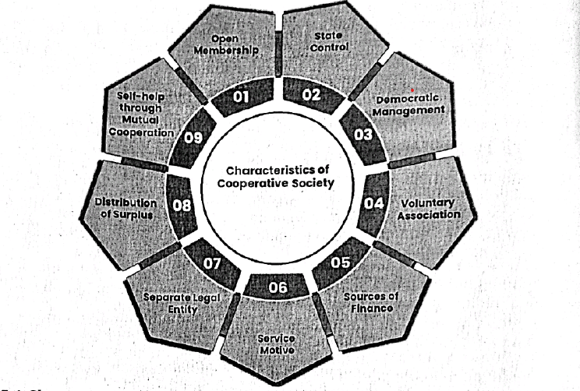

##### **Conditions for the success of cooperative**

1. The cooperative needs to produce visible and tangible (economic and social) benefits for its members, which should outweigh the costs involved in cooperation.
2. The cooperative should have motivated, experienced and dynamic managers who are able plan and implement business policies.
3. The structure and management of the cooperative should correspond to the capabilities o members.
4. Members should participate both as members and users. Members have both rights and obligations of participating in goal setting, decision-making and control or evaluation processes of the cooperative.

**Structures That Govern Cooperatives**

The governing structures help to lead or guide or direct the operation", and handle the day-to-day operations/activities of the cooperative. The basic structure of cooperative leadership and management has three parts or organs.

* 1. The members of the co-operative society
  2. The board/committees put in place by the members to lend their cooperative
  3. The staff who are hired by the board/committee to handle the day-to-day operations.

**Management structure of a cooperative**

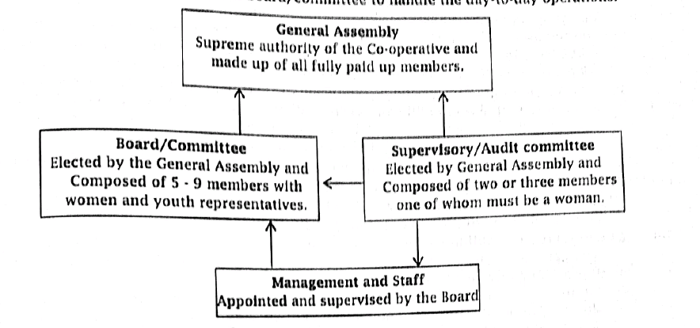

**Qualities of a good cooperative leader**

The success of any cooperative depends, more than anything else, on the quality of its leaders, the men and women elected or appointed to different positions in the cooperative's leadership/governance and management organs. It is therefore absolutely necessary that a cooperative leader should possess and exhibit the following leadership qualities:

* + Dedication and loyalty to the co-operative cause and the community at large,
  + Trustworthiness and honesty,
  + Good knowledge of the co-operative business model,
  + Objectivity and fairness,
  + Listening and consensus building,
  + General business aptitude,
  + Ability to make logical Judgment on a wide range of cooperative issues,
  + Good time keeping,
  + Visionary,
  + Good education,

##### **Indicators of good governance in a cooperative,**

These are the guidelines that will ensure good governance by the leaders of a co-operative if it is to achieve its objective and most importantly, serve in the best interests of its members:

1. Participation: Members' active participation in their own development is central for good, effective and efficient leadership and management. All women and men who are shareholders in any co-operative should have a voice in the decision-making process either directly or through the organs that represent them. such participation should be fair and free of intimidation, duress or undue influence.
2. Transparency: All processes, decisions and relevant information should be conducted in a transparent manner and should be accessible to all those concerned.
3. Accountability: All decision-makers; Committee members (including the loans committee members), Audit Committee and Management staff must be accountable to their immediate supervisors or higher organs and ultimately, to the members Certificate (through of Lower the AGM). Secondary Education
4. Consensus Orientation: There is bound to be differing interests, views and opinions by different people in a co-operative. It is therefore important to reach a broad consensus on matters critical to the co-operative's operations. This will best be achieved through an all-inclusive participatory approach, transparent systems and operations, and full accountability of the shareholders.
5. Efficiency and Effectiveness: The governance and management organs of the Co-operative must have policies, processes and procedures,' which produce results. The results should meet the needs of members.
6. Equity (fairness to all) All members should have equal opportunities to benefit from the C operative's services in order to improve their economic status and share in the vision of cooperative. They should thus. be equally given the co-operative's opportunities and services.
7. Respect for Rules, Policies and Regulations: The legal framework and policies under which operatives are regulated and operate should be respected, strictly and impartially enforce They should be made known to all members at all times. The co-operative's Bylaws and any other operating policies and regulations should always be complied with.
8. Strategic and Visionary Leadership: The co-operative must have leaders and managers who have a vision for and commitment to the organization. The leaders and managers should and improve their institutions and do all that is necessary to satisfy the needs of their members and the communities in which they are based.
9. Knowledge and Skill in Leadership and management: The members of the governance and management organs should be knowledgeable and trainable in the matters of the co-operative's governance, management and operations.
10. Organizational Growth: Co-operative growth both in size of operations, membership and geographical outreach is often an indication of good co-operative leadership/governance management. Continued growth of the co-operative will result in its survival and sustainability in the long-term.

**The role of co-operatives in economic development of Uganda**

1. Co- operatives provide savings and credit facilities to their members through granting of loans and credits to member collectively. This is done through credit and saving societies (SACCOs). 
2. Co-operatives have pooled farmers together so that they can now produce on a large scale, which enables them to enjoy economies of large-scale production. This has increased total agricultural output, mainly with respect to food crops, e.g. maize, beans, potatoes and 0th like cotton and iii. Co-Coperatives transport members' produce; co-operatives have purchased special lorries trailers and containers, to transport cotton and other forms of produce. Produce is transported from rural areas to stores, processing centres, local markets, and international  markets to date cooperatives are supporting rural development.
3. Some co-operatives are involved in processing of farmers' produce e.g. ginning of cotton, extraction of cotton seeds to manufacture edible oil, e.g. the Lint Marketing Board in Uganda Others are dealing in pulping of coffee, and processing of milk.
4. They reduce costs of marketing; they replace many small traders who are scattered, and in  high marketing costs, since they do not enjoy economies of large-scale production. This is because the co-operatives are in a position to have large storage facilities, a large transportation capacity, and they reap economies of scale.
5. They market farmers' produce marketing cooperatives locate profitable markets for the farmers, reduce competition among farmers, and save them from exploitation by middlemen.
6. Mobilizing savings from farmers through contribution of some money towards the movement. This means that co-operatives provide services of mobilizing small savings an credit facilities. Mobilized savings are used to improve farming, marketing, and land  development. Some funds are loaned to members.
7. They provide education and training to farmers and workers. Farmers, through co-operative are provided with effective medium of education on matters concerning good agricultural methods, and management techniques.
8. The co-operative movement provides employment to many people in various fields. These include unskilled labourers such as cleaners and loaders and skilled labourers, such as accountants, managers, clerks and others. Employment has been created in co-operative banks, manufacturing trade research, transport, etc.
9. Co-operatives have facilitated an increase in agricultural produce through provision of tools and equipment and essential inputs, like fertilizers, pesticides, and herbicides. These are sold to farmers at controlled prices, or given on credit terms.
10. Many co-operatives invest member funds in purchasing buildings, estates, factories, and motor vehicles for transport. This encourages development of the economy.
11. Storage: Many stores have been built in which agricultural goods are stored, pending transportation to processors or markets. Other items stored by cooperatives are farm inputs, e.g. seeds, chemicals and feeds.
12. Price stabilization: co-operatives stabilize prices of goods, because they store them, for resale when shortages arise. In this function they serve as middlemen. This has improved the standard of living of farmers through stable incomes.

**Problems faced by cooperative societies in Uganda**

1. Lack of skilled management personnel: most farmers are illiterate and, thus, incompetent in organizing cooperative routine activities. The positions of chairman, clerk, manager, secretary, treasurer, and many others require competent people.
2. Lack of funds to finance cooperative objectives: most farmers are small-scale, poor peasants, earning very little income.
3. Insufficient loanable funds to handle big demands, as our membership grows also the demand for big money increases.
4. Inadequate storage, post-harvest handling and agro-processing infrastructure
5. Massive frauds by management staff and committees • High level of dishonesty and lack of transparency on the part of committees • Lack of cooperative member education.
6. Co-operatives lack enough trucks and lorries to transport farmers' produce. Rural feeder roads are also poor and usually muddy.
7. Shortage of storage facilities: cooperatives lack large stores and warehouses, particularly in the rural areas.
8. Members failing to pay back loans given to them by co-operatives. For example, farmers sell their produce to middlemen on cash basis, in order to avoid deductions by cooperatives as a payment for supplied inputs and credit. This reduces the co-operatives' business activities ix. Fluctuation of produce prices, both locally and internationally. This tendency discourages farmers' incentives in cooperatives and agriculture as a whole.
9. High risks and uncertainties: agricultural particularly is faced with many risks and uncertainties. These discourage farmers
10. Irregular payment for farmer's products: this discourages farmers' efforts thus, reducing the level of business in the cooperative.
11. There is government interference with the day-to-day running of the co-operatives.
12. Corruption in the day-to-day running of co-operatives: cooperative officials receive bribes in order to cover up irregularities. Other forms of corruption include nepotism and tribalism affecting employment.
13. Some level of political interference from the local politicians

w. Lack of access to reliable markets that pay competitive prices.

**Improving cooperatives in east Africa**

1. Create a cooperative based on common interests, for example, coffee, cotton, tea, milk,
2. The memorandum of understanding should be agreeable to all the members. 
3. Cooperatives should base their leadership from bottom upwards, by making sure that issues are discussed bottom up before decisions are taken.
4. Cooperatives should be transparent in their day to day activities, to make sure members discuss openly and freely key decisions before they are passed.
5. Avoid politics in the cooperatives because this causes division of members.

**Reasons for successful cooperatives in Uganda**

Visionary leadership, Good governance, good business plans, Continuous member education, Market access, Accountable, honest and transparent leadership, Good management information system, Separation of roles between committees and staff, Adherence to laws, policies and procedures by all the members of the cooperative including leaders.

**Self-Help Groups**

Self Help Groups (SHGs) are voluntary and informal associations of people who come together f the purpose of solving their common problems through self-help and mutual help. While self-h might imply a focus on the individual, one important characeristic of' self-help groups is the idea of mutual support; people helping each other. Self-Help Groups include.

I. Village Savings and Loans Associations (VSLAs)

1. Saving and Credit Cooperative Society (SACCOS)
2. Savings and Internal Lending Communities (SILC)
3. Rotating Savings and Credit Associations (ROSCAs)
4. Accumulated Savings and Credit Associations (ASCAs)
5. Farmer Field Schools (FFS)
6. Farmer Groups

**Importance of self-help groups and reasons why farmers engage with them**

1. Self-help groups build a block of organization of the rural poor.
2. They provide loan to members at a low rate.
3. They act as a go-through for formal banking services to reach the poor, mainly in rural areas
4. They act as pressure groups through which pressure can be mounted on the government act on important issues.
5. They also encourage the habit of saving among the poor.
6. They also resolve conflicts via mutual discussions and collective leadership. vii. They are an important source of microfinance services to the poor. viii. They borrow loans from each other without any collateral.
7. They empower women SHGs help steer the nation towards true gender equality.
8. They encourage people to save and promote banking literacy among the rural people.
9. They enhance the efficiency of government schemes; SHGs help implement and impr0Ve t efficiency of government schemes. They also help reduce corruption through social audits.
10. They give a voice to the otherwise underrepresented and voiceless sections of society.
11. They help the disadvantaged people to be financially independent.
12. They offer collateral-free loans to people that generally find it hard to get loans from banks

They provide an alternative source of livelihood/employment; SHGs help people earn their livelihood by providing vocational training, and also help improve their existing source of livelihood by offering tools, etc. They also help ease the dependency on agriculture.

**Self-Help Group Principles**

A self-help group shall conform to the following principles; accountability, zero tolerance to arrears, group independence, group financial transactions, time bound action audit, creativity, social cohesion, mutual trust, and group equality and diversity.

1. Group independence; A Self-Help Group is a member owned group that must be nurtured to operate and run its affairs, make key decisions without interference from non- members.
2. Zero tolerance to arrears; Group adherence to external rules and internal controls to timeline payment so that the group does not make losses. Delinquency shall be handled in accordance with the group's constitution.
3. Group financial transactions; The SHG shall primarily lend to members and in special circumstance can lend to non-members if approved by the General Assembly.
4. Funds security; The group may own an account in a regulated financial service provider, mobile wallet or a metallic box called a tool kit for safety of the group funds or a group account. The metallic box should have an equivalent of three padlocks/pins and should only be opened in the presence of members during a group meeting.
5. Time bound action audit; Members of a Self-Help Group must decide on the timelines they are supposed to end their saving cycle as the time they will share out their assets. Usually this period should range between 8-12 months depending on the context. This should be decided before saving starts and included in the group's own determined internal rules and regulations.
6. Social cohesion; This is the sense of solidarity among members in a SHG. Poverty and social injustice cannot be overcome until all men and women have equal rights and opportunities. The principle of social cohesion must therefore not lose sight of its original objective of reducing economic, social, ethnic and territorial disparities.
7. Mutual trust; This refers to the confidence that each member will fulfil their obligations and behave according to the group constitution.

**Problems/challenges of self-help groups**

1. Lack of knowledge and proper orientation among SHG-members to take up suitable and
2. Patriarchal mindset - primitive thinking and social obligations discourages women from participating in SHGs thus limiting their economic avenues.
3. Ignorance of Members/Participants: Even though the authorities take measures for creating awareness among the group members about the schemes beneficial to them. still majority of the group are unaware of the schemes of assistance offered to them.
4. Inadequate Training Facilities: The training facilities given to the members of SHGs in the specific areas of product selection, quality of products, production techniques, managerial ability, packing, other technical knowledge ate are not adequate to compete with that of  Strong units.
5. The problem of marketing; Marketing is an important area of functioning of the SHGs.

However, they face different problems in the marketing of products produced by them.

Following are the major problems relating to marketing.

1. Lack of sufficient orders.
2. Lack of linkage with the marketing agencies.
3. Inadequate sales promotion measures.
4. Lack of permanent market for the products of SHGs.
5. Absence of proper brand name.
6. Poor/unattractive packing system.
7. Poor quality of products due to the application of traditional technology, resulting  poor market,
8. Stiff competition from other major suppliers.
9. Lack of a well-defined and well-knit channel of distribution for marketing.
10. Lack of stability and unity among the members: in most cases, there is no unity among the members owing to internal conflict and deviation from the SHGs goals.
11. Exploitation by Strong Members: In the case of SHGs dominated by women, it is found there is no stability of the units as, many married women are not in a position to associate with the group due to the shift of their place of residence. Moreover, there is no unity a women member owing to personal reasons.
12. Weak Financial Management: It is also found that in certain units the return from the bus is not properly invested further in the units, and the funds diverted for other personal domestic purposes like marriage, construction of house etc.
13. Low Return: The return on investment is not attractive in certain groups due to inefficient management, high cost of production, absence of quality consciousness etc.
14. Inadequate Financial Assistance: It is found that in most of the SHGs, the financial assist provided to them by the agencies is not adequate to meet their actual requirements. financial authorities are not giving adequate subsidy to meet even the labour requirements. 
15. Non-co-operative Attitude of the Financial Institutions: The Financial institutions do consider SHGs seriously while providing finance and other help.
16. Inadequate and ill-trained staff to meet the challenges: The attitude of the staff of the development department is not encouraging. They are not well trained to accept challenges and equip the SHGs self-reliance.
17. Inadequate Support from Line Department: For obtaining assistance and support, the gr members have to approach the line officers. However, the line officers are not co-opera with the SHGs. This will hamper the very objective of the schemes.

**Suggestions to minimize the problems faced by SHGs**

The following suggestions are offered to minimize the above-mentioned issues of SHGs:

1. Information about locally available materials and their varied uses should be disseminate SHGs. Proper encouragement and training should be given to them to make innovative products by using these materials.
2. In order to solve the various problems relating to marketing of SHGs, the government should provide information on the available market opportunities to the SHGs.
3. Various SHGs functioning in a particular area can form a co-operative society. This society may be entrusted with the task of marketing the products of different SHGs under a common brand name. Further, the society can undertake sales promotion activities and procure raw materials for the benefits of member SHGs.
4. Non-Government Organisations (NGOs) can play a significant role in empowering wo entrepreneurs by providing basic education, motivation training, and financial help.
5. All the members in the SHGs may not have the same calibre and expertise. NGOs can identify the inefficient members of the group and can impart proper training to them in order to make them competent. For this purpose, short term training programs can be arranged at the sub county level.
6. Frequent awareness camps can be organised by the Rural Development department authorities to create awareness about the different schemes of assistance available to the participants in the SHGs.
7. Lastly, arrangements may be made by the financial institutions for providing adequate financial assistance to the SHGs strictly on the basis of their actual performance without any discrimination of caste, politics etc.

*Theme:* ***Crop/Animal Production***

**Value Addition to Agro Wastes and By-Products**

**Competency:** You should be able to manufacture biofuels and handmade paper to preserve the environment.

**Learning outcomes;**

1. By the end of this chapter, you should be able to;
2. Know materials used to in making paper, biogas and briquettes.
3. Show creativity and skills in utilizing domestic animal wastes
4. Be able to make uncarbonized and carbonized briquettes from crop and animal domestic wastes
5. Understand how handmade paper is manufactured.

## **Introduction**

Agriculture waste is a term used to describe the residue material produced during crop and animal production and processing of the raw farm products. Agriculture generates a number of agro wastes and by-products which when added value can produce other useful products that are environmentally friendly and of a high market value. Examples of agricultural wastes include; residues after harvesting and processing crops, manure, weeds, tree trimmings, farm wastewater (from cleaning activities), waste feed, agricultural chemicals and all the packaging (boxes, paper and polythene bags, metallic and plastic containers) used in the production and supply chain.

Agricultural by-products are residual materials produced before and after processing farm  products. They include residues from the market and from processing plants.

Agricultural wastes and by-products in most cases are just disposed off with no value added.

Improper handling of farm wastes and by-products can lead to pollution of the environment and their accumulation has negative effects on humans and the entire ecosystem.

The fig. below shows two different types of agro-industrial wastes, i.e., agricultural residues and industrial residues. Agriculture residues are further divided into field residues and process residues. Field residues are residues in the field after the process of crop harvesting or cleaning of the animal premises, whereas process residues are residues present after the crop is processed into alternative valuable products. Such as peeling, Dehusking, shelling, decorticating, hulling etc.

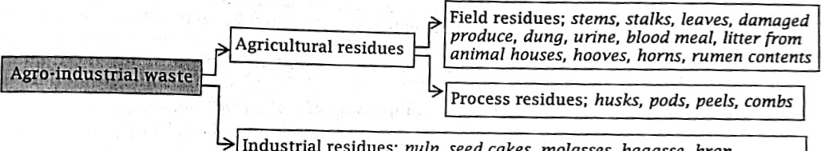 Industrial residues; pulp, seed cakes, molasses, bagasse, bran

*Types of agro-industrial wastes.*

**Table shows products from different agro wastes and by-products**

|  |  |  |
| --- | --- | --- |
|  | Agro waste/by-product | Utilized |
| 1 | Field crop residues and weeds | * Processed into growing medium for mushrooms * Crushed and used to manufacture paper * Processed into biofuels such as briquettes * Decomposed into compost manure * Processed and used for feeding livestock * Used as mulch |
| 2 | Animal wastes (dung and droppings from poultry) | * Decomposed and used as manure * Used in production of biogas * Processed into feeds for pigs and poultry |
| 3 | Husks, pods, hulls, cobs | * Processed into paper * Processed into growing medium for mushrooms * Used in making of biofuels (briquettes) * Used as litter in animal houses |
| 4 | Peels and green waste | * Processed into animal feeds * Decomposed into manure * Used in making of biofuels (briquettes) |
| 5 | Cakes, pulp, molasses | * Processed into animal feed supplements |
| 6 | Packaging materials; plastic and papers | * Recycling into new products of raw materials for manufacturing. |
| 7 | Blood meal, eggshells, bones | * Processed into animal feeds * Processed into mineral supplements for humans and farm animals. |

**Agriculture Waste Management**

Agricultural waste management refers to all the coordination, handling and controlling of the waste generated from agricultural activities. The primary goal is 'to prevent soil and water pollution, greenhouse gas emissions, and health risks for humans and animals. An effective agricultural waste management system should focus on the following: waste reduction, recycle and reuse. These turn waste into valuable resources like organic fertilizers, feeds, fuel or green energy like biogas and industrial raw materials.

**Benefits of agricultural wastes and by-products management**

* It reduces the risk of contaminating the environment and preserves the ecosystem.
* Farmer can make natural fertilizers, which leads to supporting sustainable agriculture.
* Farmers can-save on waste disposal costs by using wastes for biofuels or composting.
* Provides extra income to farmers by selling processed agro wastes such as plastics, fertilisers and papers.
* It enhances food safety by minimizing exposure to harmful chemical and pathogens.
* It improves community health by processing wastes which can be potential source of infections.
* It may help in production of raw materials for industrial use such as processed paper, plastics and metals.
* Provides employment to individuals or companies who are engaged in processing and recycling of agro wastes.

**Waste Materials used for Making Paper, Biogas and Briquettes**

**Materials used in Making Paper**

Paper is a thin sheet material produced by mechanically processing cellulose fibres derived from wood, rags, grasses, banana fibres, cotton and other sources. Paper has many uses, including printing, writing, packaging, decorating, and cleaning. It can also be used in industrial and construction processes.

There is a wide variety of materials used to make paper.

**Fibres:** Regardless of the source, you need fibre to make paper. The length of the fibre plays an important role in the quality of paper. The common materials that provide fibre include; Cotton, rice or wheat straw, jute, sugar cane waste, bamboo, saw dust, linen rags, water plants, waste paper and wood shavings.

**Binders:** starch is used as a flocculant, and a bonding agent. The major starch sources are maize, potato, wheat and tapioca.

**Fillers:** Other than the fibres, pulp may contain fillers such as chalk or clay which improves it characteristics for printing or writing.

### **Chemicals used in Paper Making.**

Many chemicals are used in paper making. These chemicals are used to prepare and modify the raw materials and to modify the properties of the paper produced. Table 6.2 shows the common chemicals used in the making of paper.

Table showing Common chemicals used in the making of paper.

|  |  |
| --- | --- |
| **Chemical** | **Role in paper making** |
| Alum (Sulphate of alumina), clay | Surface sizing (making water or ink proof) |
| Chlorine, sodium chloride, Hydrogen peroxide, Zinc hydrosulphite | Pulp bleaching |
| Dolomite (Calcium Magnesium Carbonate), Titania | Filler, coating and improves print retention |
| Caustic soda, Sodium sulphides, Sulphur dioxide | Dissolving lignin and separating wood fiber |
| Melamine, Starch, Cellulose, Urea formaldehyde | Improving paper strength |
| Caustic soda, Sulphuric acid, Chlorine | Removing impurities from the pulp |
| Sodium silicate, Sodium hydroxide, H. peroxide | Deinking waste paper |

### **Preparation of Material for Making Paper**

**Dirty linen:** wash to remove any dirty, bleach/deink if needed, and disinfect. Cut to small pieces

**Fresh plants:** select suitable plants with high fibre content. Scrape the material to obtain the fibre.

Cut the material to small pieces, boil in washing soda solution for about 3 hours, drain and rinse to make it ready for mix into slurry.

**For dry plant material:** chop to small pieces, soak the material for overnight until the material softens, boil in a washing soda solution and rinse.

**Equipment for Making Handmade Paper** Deckle

**Mould:** it is fixed with a screen (fine mesh). It is used to collect a sheet of pulp from the slurry in the container.

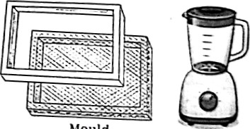

Mould

**Deckle:** this is a frame or 'fence', placed on the mould to keep the paper pulp slurry on the screen, and to control the size of the sheet produced.

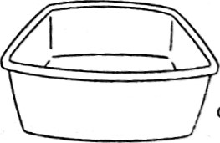**Paper Press:** made up of two boards. Wet paper is placed between the boards and pressed to drain excess moisture Blender

**Blender:** it is used to chop, beat and mix the raw materials

**Drier:** made of steel and is heated by steam at high temperatures. Used to dry the paper container

**Plastic container (vat):** this should be larger than the mould and deckle. It is used to hold the pulp slurry.

Other items needed include; Absorbent material, such as felt, a sponge, and two cover screens. **Materials used in making Biogas.** Biogas is an environmentally-friendly renewable energy produced by anaerobic breakdown organic matter such as animal waste, crop residues, municipal waste, sewage and food left These materials contain carbon, among other things, and during anaerobic fermentation, carbon is transformed into biogas, a compound of methane (CFI,) (50-70%) and carbon dioxide (30-50%). It also contains small amounts of hydrogen, hydrogen sulphide, nitrogen, ammonia other gases. Its precise composition depends on the organic matter used for its production. clean source of energy, Biogas is used as a cooking gas.

1. It can be used for the production of electricity.
2. It can be used in equipment used for water heating and space (room) heating.
3. It can replace compressed natural gas for use in internal combustion engines.
4. Renewable methane and carbon dioxide in biogas can be used in hydrocarbon production make different kinds of plastic instead of using fossil fuel (oil and natural gas).
5. The by-product of biogas (Digestate) can be used as organic fertiliser in crop growing.

**Note;** By using biogas; It can substitute fossil fuels like natural gas, propane or wood, reducing over reliance on non-renewable energy sources. It reduces on emission of greenhouse gases e.g. methane, carbon dioxide and nitrous oxide, it allows reuse of organic wastes that would otherwise pollute the environment and is free from animal and plant diseases, nutrients in the slurry are readily available to crops and the slurry is of low cost as compared to artificial fertilizers.

**How to Make Biogas at Home**

You will first need a biogas digester (also known as a biodigester or anaerobic digester). This sealed container enables microorganisms to break down organic materials without oxygen. The process is called anaerobic digestion.

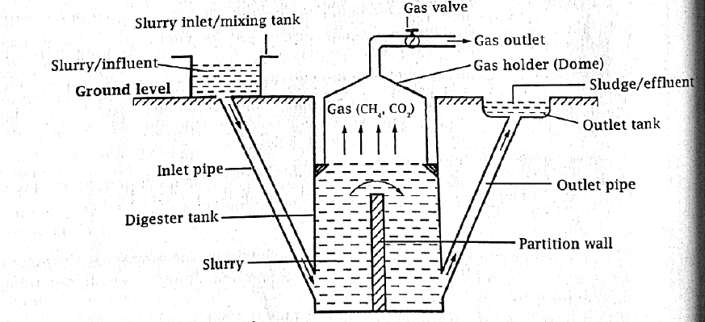

*Setup of a biodigester system*

**Component of Biogas Production System**

1. **Digester tank;** it is a sealed container where the anaerobic digestion takes place. It can be made of steel, plastic, concrete or heavy-duty polythene bag.
2. **Feeding system (inlet);** an inlet pipe or opening that allows you to introduce organic waste into the digester.
3. **Stirring system;** it can be a mechanical or hydraulic mixer. It prevents the formation of  floating layers and accelerates the fermentation process.
4. **Gas collection system;** a gas outlet pipe connected to the digester and transport the biogas to the storage unit or the end user device. It also has gas valves to control the gas flow.
5. **Ventilation;** an exhaust Pipe or vent that prevents the accumulation of potentially harmful gases like hydrogen sulphide inside the digester.
6. **Temperature control;** depending on the location, you may need heating device to maintain an optimal temperature for bacteria to thrive inside the digester.
7. **Digestate outlet system;** an outlet pipe to remove Digestate from the digester.

**Stages of Fermentation Process**

There are four stages involved in the breakdown of organic matter to produce methane Figure 6.4; The first phase is the Hydrolysis involving the conversion of carbohydrates, lipids and proteins found in organic matter into simple sugars, long chain fatty acids and amino acids respectively. The second phase is the Acidogenesis involving conversion of these products into volatile fatty acids, acetic acid, C02 and H2. The third phase is the Acetogenesis which involves conversion of volatile fatty acids into more acetic acid, carbon dioxide and hydrogen gas. The fourth phase is the Methanogenesis which involves the conversion of carbon dioxide and hydrogen gas into methane.

*Stages of fermentation of organic material in the biodigester to produce biogas*

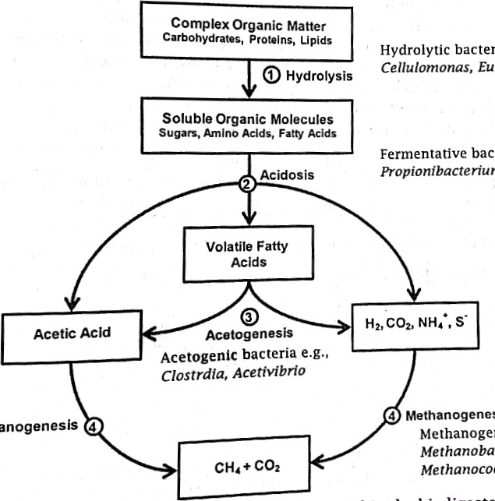

***Methanogenesis: Methanogenic bacteria e.g., Methanobacterium, Methanosarcina, methanococcoides***

***Hydrolytic bacteria e.g. Bacillus, Cellulomonas, Eubacterium***

,

ia

bacteria

, ***Butyrivibrio, Acetivibrio***

**Procedure for making Biogas**

1. Create a biogas digester system; different types of digester system have different designs.
2. Collect organic waste suitable for biogas production; Common sources include food waste, kitchen scraps agricultural residues, animal manure, or plant materials. Remove any
3. Prepare the digester; clean the digester and ensure all the pipe connections are properly
4. Mix and load organic waste in the biodigester; Mix the organic waste with water thoroughly (ratio 1:1) to create homogenous slurry. This ensures rapid fermentation of organic waste.
5. Ensure optimal operating conditions; to ensure proper fermentation of organic waste inside the digester, ensure the temperature of about 30 to 400C and pH level of about 6.5 to 8.0.
6. Capture and store the biogas; collect you gas collecting system to gas storage tank.
7. Use the biogas; connect the gas storage tank to the end user devices such as gas burner, stoves, generators, or any equipment specifically designed to use biogas.

**Safety Precautions**

* Anaerobic digestion releases potentially harmful gases like methane and hydrogen sulphide inhaled in high concentrations, they are toxic and pose significant health risks.
* Accumulation of biogas in enclosed spaces can lead to dangerous situation because biogas highly flammable.
* The equipment used for biogas production such as pumps, mixers, or gas collection syst may present mechanical hazards if not properly maintained.
* Improper management of digestate can lead to pollution of the environment.

***Ho to Reduce Risks and Hazards in Biogas Production***

* Build your biogas system properly
* Make sure all pipe connections are properly fixed to reduce gas leakage
* Work in well-aerated/ventilated space to prevent build-up of potentially harmful gases.
* Install gas detectors or sensors near pipes and devices that use biogas.
* Keep the biogas production area clear of flammable materials
* Keep away any source of fire; avoid naked flame or smoking
* Have fire extinguishers in place to put off any fire that may break out.

### **Materials used in Making Briquettes**

Globally deforestation is at alarming rate. This of course damages the climate. As trees act as carbon sink to clean the atmosphere of greenhouse gases. The loss of trees is contributing to global warming. With the severity of climate change, there is a need for green energy to reduce carbon emission and environmental pollution. On the other hand, the prices of firewood. charcoal and electricity have been increasing dramatically, making it less affordable for most users. So, what alternative is the market offering these people? How do we use the abundant organic wastes in the community to provide alternative energy source? Briquettes! Briquettes! The briquettes come in handy to fill this gap. Briquettes have been proved to provide a low-cost fuel for households, factories and institutions.

A briquette is a compressed block of combustible biomass material e.g. organic agro-waste, household wastes and forest wastes. Processing the biomass into compact, evenly sized pieces such as briquettes or pellets allows the biomass to burn more efficiently and evenly, increasing their energy density and transportability. The compactness of a briquette increases heating and thermal value of the briquette. In fact, briquettes are 40% more efficient, as well as hotter and long lasting than firewood. Briquettes making will also help to provide a mechanism for recycling organic wastes to reduce on soil, air and water pollution, and to protect the ecosystem.

**Note:** Organic, materials create methane gas when left to decay which is even more harmful to the environment than carbon dioxide. Using the make briquettes can prevent the negative by-products of decomposition process. Briquettes release less greenhouse gases and burn cleaner than firewood.

Briquettes are used to provide heat for the following purposes;

1. Used in cooking and water heating in households and institutions e.g. schools and hospitals.
2. Used in productive processes to provide heat for curing and drying of crops.
3. Used in firing of furnaces, incinerators and kilns.
4. Use in indoor heating of houses during cold weather or to provide heat in brooding houses.
5. Powering of boilers to generate steam.
6. Fueling as gasifiers to generate electricity.

**Advantages of using briquettes over traditional firewood**

1. Do not need chopping as is the case with traditional firewood.
2. Clean and easy to ignite, produces less smoke and ash. Briquettes have a larger surface area open to combustion, which means less smoke and more heat.
3. Produces hotter flame thus cooks faster.
4. The compression process allows the briquettes to burn for longer than firewood
5. Easy to transport and store, not bulky and requiring less space.
6. Reduces on deforestation and thus helps in the forest and environmental conservation.
7. Cheaper as compared to firewood.
8. Raw materials for briquetting are abundant in many communities, and productive use o them could save on the cost of waste disposal.
9. Briquettes are consistent in size and shape and ready to use upon purchase, so the same amount of energy is given during each use, unlike firewood which vary in size, moisture' content and temperature making it difficult to determine how much fuel is needed.

**Materials for Making Briquettes**

**I. Heat fuel;** crop residues such as cereal straws, maize cobs, soybeans haulms, beans ha sunflower straw, rice husks, sunflower seed hulls, coffee husks, cassava stems, bag cotton stems, peanuts haulms, banana stem/peals, weeds, forest wastes and wood products such saw dust, wood shavings, wood chips, waste paper and charcoal dust.

1. **Burning enhancers/accelerants;** added to increase the rate of burning and heat production

E.g., sodium nitrate and waxes.

1. **Binders (agglomerating materials);** added to bind the materials together e.g., starch, molasses, gums, cement, clay and lime.
2. **Filler or bulking material;** added to increase the weight, density or volume e.g., cassava flour, clay, soil, silica etc.

**Equipment used in making briquettes**

Briquette press, carbonization furnace, crusher and dryer and packager.

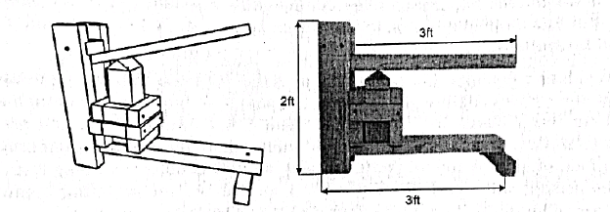

*Hand pressing machine.*

**Barriers to Adoption of briquettes**

1. Lack of awareness among potential producers and consumers.
2. Lack of appropriate financing mechanism for businesses.
3. Lack of stable supply of briquette fuel in the market.
4. Consumer bias in favour of traditional fuels.
5. High costs associated with ingredients and equipment.
6. Readily available firewood and charcoal in most areas.
7. Distribution in rural areas can be problematic.
8. Perceived risk of investing in plants where briquetting is a new technology.

### **Carbonised and Uncarbonized Briquettes**

There are two main types of biomass briquettes;

1. Uncarbonized fuel briquettes: these are produced from fresh organic waste materials that are not carbonised such as dry cereal straws, saw dust and waste paper.
2. Carbonised fuel briquettes: these are made from organic waste materials that have undergone carbonization (the conversion of organic substances into carbon in the absence of oxygen) such as charcoal dust or carbonising non-carbonised briquettes. Carbonization process evaporates the Water and breakdown the cellulose and lignin and leave carbon in the form of charcoal as material for making briquette.

**Making Uncarbonized Fuel Briquettes**

Here the raw materials are directly used to make briquettes. The raw material is usually soaked for a few days to allow it to ferment partially and then compressed to make briquettes of different sizes and designs. When compressed effectively, the lignin in the plant tissues is liberated and binds the particles together to form a stable briquette of high density.

*Procedure;*

1. Put on protective gear.
2. Prepare all the ingredients such as organic wastes (mainly crop residues and by-products or wood wastes), binders, fillers, and burning enhancers, and equipment required such as the press, crusher, dryer and packaging.
3. Sort/remove foreign objects such as glass, stones, soil lumps, plastic and large wood pieces.
4. Chop/crush the organic material into small pieces for easy feeding into the press and for ease of pressing.
5. Soak the raw material for about a week to partially ferment. This reduces the level of carbon compounds in the raw material thus reducing smoke emission from briquettes during burning.
6. Dry the raw material in the sunshine or a dryer to moisture level of about 15 to 20%.
7. Add some binders such as such as starch or gum if the base material is not holding together.
8. Place the raw material into the press. Feed the material in press gradually. The raw material is compressed under high pressure, which causes the lignin and gums in the wood to be released so that it binds the material into a firm briquette.

#### **Making Carbonised Fuel Briquettes**

Here the organic material is first partially burned in an environment of limited oxygen supply. The Process is known as charring or carbonization. Once carbonised, the materials are then compacted into briquettes. The advantage with carbonised briquette is that they are virtually smokeless making them suitable for household users.

***Procedure of making charcoal from agro-waste***

There are two ways of making charcoal from agro-waste, one is directly carbonising the material into charcoal through carbonization furnace, and then compressing the charcoal into briquette. The other is to compress the raw material into briquettes first and then carbonise the briquettes into charcoal. The following is the general procedure of carbonising agricultural waste;

1. Put on a protective gear
2. Collect and sort the material. Remove the metals, plastics, soil lumps, stones and glasses.
3. Dry the material in sunshine until it is about 15 to 20% moisture content.
4. Place the material the furnace
5. Light up the furnace and then close the cover to limit oxygen in the combustion chamber.
6. Carbonise the material until the level of smoke emission reduces and the material turns
7. Open the furnace and sprinkle the material with water to put off the fire and to cool it
8. Remove the carbonised material (bio-charcoal) and used to make briquettes.

**Note:** The procedure listed above is general for most large-sized materials. However the

|  |  |  |
| --- | --- | --- |
| procedure may somewhat change depending on the type of carboniser used. | |  |
| **Procedure of making charcoal briquettes** | | **Raw Materials** |
| i. | Prepare all the ingredients and equipment required  e.g. charcoal, crusher, binder and press. | **Carbonation** |
| ii. | Crush the charcoal into small pieces of about 5mm. use a mallet or a crushing machine. | **Crushing** |
| iii. | Dry the charcoal if the water content is above 15% | **Drying** |
| iv. | Add binders such as cassava flour or clay and |  |
|  | enhancers if necessary and mix until the mixture is homogenous. | **Compressing/MouIding** |
| v. | Sprinkle some water into the mix. |  |
| vi. | Place the charcoal mixture into the mould and then compress it to proper consistence. | **Drying** |
| vii. | Dry the briquettes in the dryer or in the sun and then | **packaging** |
|  | pack immediately. | Steps in the making of charcoal briquettes |

**Making handmade briquettes from charcoal dust**

There are different formulas for handmade briquettes. You can choose any one for use in the preparation of your handmade charcoal briquettes.

*Formula 1;* 10 kg charcoal dust/fines and 0.3 kg cassava starch.

*Formula 2;* 10 kg of charcoal dust/fines, 5 kg saw dust, I kg cassava starch and 0.5 limestone.

*Formula 3*; 40 kg charcoal fine/dust, 4 kg saw dust and 2.5 kg clay

*Formula 4;* 3 kg charcoal dust, 1 kg dry cow dung

***Procedure;***

1. Prepare all the materials and equipment to use.
2. Ferment the saw dust by soaking in water for about five days. This will carbonise the saw and reduce the smoke emission.
3. Sieve the charcoal to remove big particles and the poorly carbonised materials in order to

have a fine output.

1. Then mix charcoal fines, saw dust, clay and water. Water should be added gradually to the required consistency.
2. Place the mixture in the desired mould and press the material using a handmade press, vi. Remove the briquettes from the mould and then dry them in sunshine.

vii. When completely dry, pack the briquettes in bags and store in dry warm place.

Alternatively, the mixture can be moulded by making balls using hands. The balls are then coat with dry fine charcoal dust.

**Note:** Briquette can be made various shapes and, sizes depen4ing on the mould and intended use. The appearance and burning qualities, briquette depends on the type of the raw materials and enhancers used and the level of compaction. The size and shape should be designed to match the market (stove to be used). The burning quality can be enhanced by making small sized and porous briquettes.

|  |  |
| --- | --- |
| **Qualities of a good briquette** | **Improving the quality of briquettes** |
| * Should burn easily * Should be durable, thus able to burn for long time * Should be stable not to break easily * Should produce less smoke and ash. * Should be easy to use in a variety of stoves. * Should not produce dust or bad odours * Should be easy to transport and store. | * Proper sorting of raw materials * proper crushing of the raw materials * Using of raw materials of good quality • Addition of binders and enhancers. * Proper drying of the raw materials and briquettes * Proper compression during briquetting * Carbonising of uncarbonized raw materials and briquettes |

**Factors that affect the quality of briquettes**

The properties of the ingredients and the briquetting process determine the quality of briquettes;

1. The type of raw material; different raw materials have different qualities such as density, strength, combustibility and calorific value.
2. The moisture content of raw material; too high moisture content of the raw material can lead to popping, bending and cracking of the briquette.
3. The particle size of the raw material; raw materials with small particle size are easy to briquette and form a stable and burn easily and produce less ash.
4. The briquetting pressure; the higher the pressure the more stable and denser is the briquette.
5. The temperature during briquetting; high temperature softens the lignin contained in the raw material leading to effective bonding of particles which also leads to a stable briquette.
6. The amount of additive such as binders, and enhancers added to the raw material.

### **Domestic Animal Wastes**

Domestic animals and associated activities produce a lot of solid and liquid wastes. The wastes are from the dung, beddings/litter, urine, waste feeds, waste water from cleaning activities, slaughter house effluent etc.

**Processing animal wastes in particular, provides a number of benefits;**

1. Prevent direct greenhouse gases emissions from the decomposition of wastes.
2. Prevents environmental contamination through incorrect disposal (e.g., phosphate and nitrate pollution of water sources).
3. Aids in odour management.
4. The processed dung and dropping can be recycled and used for feeding livestock.
5. Can be used to provide green energy through making of biogas and briquettes.
6. The waste can be composted to provide organic fertiliser, which improve soil fertility and reduces over use of synthetic fertilisers.
7. Reduces fly problem in the community. Flies use raw animal wastes as breeding medium, flies are vectors for most community infections.
8. Processing of animal wastes reduces infections from the waste to humans and animals.

Table shows Value addition to various animal wastes

|  |  |
| --- | --- |
| faeces (dung and droppings) | * Fermented and used to generated biogas. * Dried and processed into animal feeds for poultry and pigs * Processed into briquettes * Composted into manure for soil improvement * Processed and used as a binder during construction work |
| Urine | * Fermented and processed into liquid fertiliser for soil improvement * Fermented and processed into pesticide |
| Beddings/litter | * Fermented and used in biogas production * Composted into manure for use in soil improvement * Processed into briquettes * Processed and used as mulch in crops * Processed into growing medium for mushrooms |

**Adding value to cow dung through making of biofuels**



Just like other biomass, cow dung either as single ingredient or in combination with other raw materials used to make biofuels such as biogas and briquettes. Remember cow dung has already undergone partial fermentation rumen and will need little processing.

***Procedure;***

* 1. Put on protective gear.
  2. Assemble the required materials and equipment
  3. Treat the dung with heat to dry and kill any pathogens. A dryer or furnace can be used.
  4. Crush the dung, and remove large particles.

 v. Sprinkle and mix the dung with some water.

* 1. Place the mixture in the desired mould and press the material using a press.
  2. Remove the briquettes from the mould and then dry them in sunshine or dryer.
  3. When completely dry, pack the briquettes in bags and store in dry warm place.

Alternatively, the dung can be mixed with charcoal dust in proper proportions and then pressed. The resultant dung briquette can be carbonised in the furnace in necessary.